Your choices. Your rights.  These days, we’re all aware of how important it is to keep our personal data safe and secure.  If you are aged 13 years or older then you can ask us who is allowed or not allowed to know about the care you have been given by us or the NHS. This info might be illnesses you’ve had or the medicines provided by a hospital or us.  You can ask us how we should get in touch with you, ask what is on your personal medical files, decide who’s allowed to view your medical files and ask us to stop some of the ways we use your info.  Our address and Data Protection Manager’s details:  Michaela Varley  Ayton and Snainton Medical Practice, Pickering Road, West Ayton, Scarborough, YO13 9JF  Website: www.ayton-snainton.co.uk | You have a number of rights and choices on how we use your personal information, you can:  - ask for a copy of your medical information that we have on our computers;  - ask that we update, complete or fix any information that is incorrect or missing;  - ask that we delete information or stop others seeing your private medical records;  - ask that we send your information over the internet to another care provider;  - stop NHS departments or others viewing or using your information – e.g. for research into curing or preventing illness, seeing which medicines work best or so the government can plan how much money they spend on everyone’s healthcare.  For under 16 year olds - a parent or guardian’s permission is normally needed to say OK on how personal data is used and seen by others. But, the law allows some under-16s to make their own decisions on their medical information is used if the doctor believes they are capable on their own – they call this a ‘Gillick Test’. It’s not a quiz or exam – just some questions to see if you really understand the whole picture on what’s happening to you and how it affects others. |  | Data Privacy  AGED 13 YEARS OR OVER?  - How we keep your personal data safe and secure  - 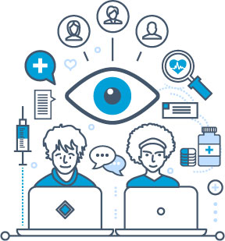  Your choices. Your rights.  Leaflet: 13-OR-OVER  Last updated: 01.10.2024

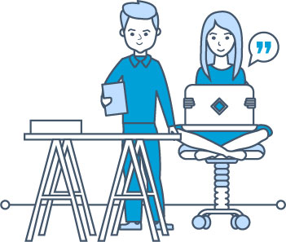  Why do we collect info about you?  Your doctor and our team of health professionals caring for you keep records about your health plus any treatment and care you receive from the NHS. These records help to ensure that you receive the best possible care. They may be written down on paper records or stored on computers. These records may include:  - Personal details such as your name, address, date of birth and your legal guardian (like a parent or someone else who looks after you)  - Contact we have with you such as surgery visits  - Notes and reports about your health and medicines prescribed to you  - Details about your treatment or care  - Results of blood tests, x-rays, laboratory tests and any other tests  - Information from people who also care for you or know you well - such as your relatives | Did you know?  NHS England requires that all types of records for children and young people should be kept until the patient is 25 years old (or 26 if they are 17 when treatment ends).  How your personal Information is used?  Your records are used to guide the care you get from us to make sure that:  - Your doctor, nurse or other health care person involved in your care have correct and up-to-date information  - There is a good information for health professionals to assess the type and quality of care you have received  - Your concerns or complaints can be properly looked into if a problem happens  - Information is available if you go to see another doctor or an NHS specialist  - We may share your information with the following organisations:  - Department of Health  - Integrated Care Boards (ICB's)  - Hospitals and Ambulance Services  - Other General Practitioners (GP’s) | With your agreement we may also share your information and tell you how it will be used with:  - Children and Young People’s Services  - Adult Services  - Social Care Services  - Local Authorities  - Voluntary Sector Providers working with NHS  - Private Sector Providers working with NHS  The law on data privacy  Our practice must obey the law and ensure that all your personal information is processed fairly, lawfully and as transparently as possible.  We will do everything we can to make sure that your information is kept safe and secure from those who are not allowed to see it. This applies to all your information whether it is on paper or computers.  Complaints  If you are worried about how your personal information is used by us please contact our Data Protection Officer - they’ll be happy to help. Just ask anyone on our team on how to get in touch with this person. If you are still unhappy after we’ve looked into your request you can then complain directly to an organisation called the ICO (Information Commissioners Office):  Website: www.ico.org.uk  Email: casework@ico.org.uk  Tel: 0303 1231113 (local rate) or 01625 545745

